Payment Processor
# Source: AI Source: Provided by: [Data Path: Persons Table -> ID Column: 1, Name_En Column: Motasem Essam] -> From: [ChatGPT] on [1/21/2026]
A payment processor is a financial service provider that handles the technical and financial communication between the merchant, the customer’s bank, and the merchant’s bank to authorize and complete payment transactions.
It acts like a middleman that ensures money moves securely and accurately from the customer to the merchant.

⚙️ How a Payment Processor Works (Step-by-Step)
# Source: AI Source: Provided by: [Data Path: Persons Table -> ID Column: 1, Name_En Column: Motasem Essam] -> From: [ChatGPT] on [1/21/2026]
- Customer initiates payment (via card, mobile wallet, or online checkout).
- The payment processor sends the transaction request to the card network (e.g., Visa, Mastercard).
- The request is forwarded to the issuing bank (customer’s bank) to approve or decline the payment.
- If approved, the processor confirms the transaction to the merchant.
- Later, funds are settled into the merchant’s bank account (via the acquiring bank).

🔄 Participants Involved in a Payment Transaction
# Source: AI Source: Provided by: [Data Path: Persons Table -> ID Column: 1, Name_En Column: Motasem Essam] -> From: [ChatGPT] on [1/21/2026]
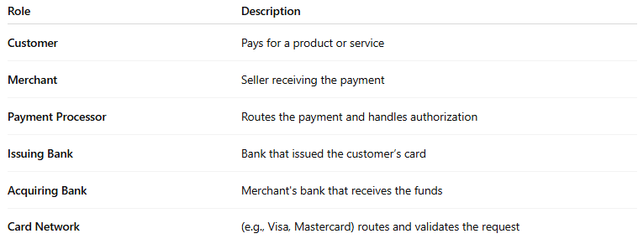

Role | Description
Customer | Pays for a product or service
Merchant | Seller receiving the payment
Payment Processor | Routes the payment and handles authorization
Issuing Bank | Bank that issued the customer’s card
Acquiring Bank | Merchant's bank that receives the funds
Card Network | (e.g., Visa, Mastercard) routes and validates the request

💳 Examples of Payment Processors
# Source: AI Source: Provided by: [Data Path: Persons Table -> ID Column: 1, Name_En Column: Motasem Essam] -> From: [ChatGPT] on [1/21/2026]
- Stripe
- PayPal
- Square
- Adyen
- Worldpay
- Paymob
- Checkout.com
- Fawry (in Egypt)

✅ Benefits of a Payment Processor
# Source: AI Source: Provided by: [Data Path: Persons Table -> ID Column: 1, Name_En Column: Motasem Essam] -> From: [ChatGPT] on [1/21/2026]
- Ensures secure and fast transaction handling.
- Supports multiple payment methods (cards, wallets, bank transfers).
- Reduces fraud risk with encryption and fraud detection tools.
- Handles currency conversion for international transactions.
- Provides reporting and analytics for merchants.

🔴 Challenges / Costs
# Source: AI Source: Provided by: [Data Path: Persons Table -> ID Column: 1, Name_En Column: Motasem Essam] -> From: [ChatGPT] on [1/21/2026]
- May charge transaction fees (flat + percentage).
- Some require monthly or setup fees.
- Downtime or delays can disrupt business.
- Must comply with PCI DSS and other security standards.

🔐 Security Role
# Source: AI Source: Provided by: [Data Path: Persons Table -> ID Column: 1, Name_En Column: Motasem Essam] -> From: [ChatGPT] on [1/21/2026]
- Encrypts sensitive payment data.
- Implements tokenization, 3D Secure, and anti-fraud filters.
- Ensures compliance with regulations like PCI DSS, GDPR.

🔄 Payment Gateway vs Payment Processor
# Source: AI Source: Provided by: [Data Path: Persons Table -> ID Column: 1, Name_En Column: Motasem Essam] -> From: [ChatGPT] on [1/21/2026]
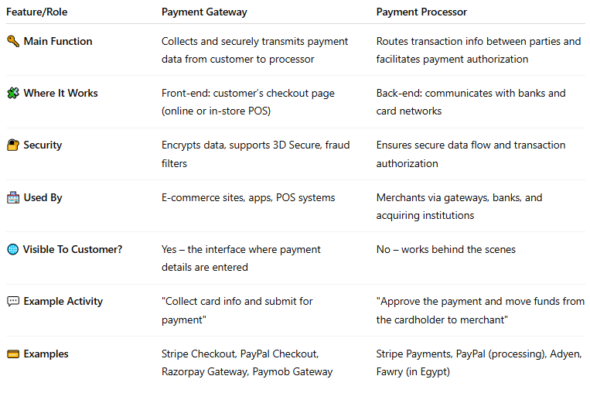

Feature/Role | Payment Gateway | Payment Processor
🔑 Main Function | Collects and securely transmits payment data from customer to processor | Routes transaction info between parties and facilitates payment authorization
🧩 Where It Works | Front-end: customer’s checkout page (online or in-store POS) | Back-end: communicates with banks and card networks
🔐 Security | Encrypts data, supports 3D Secure, fraud filters | Ensures secure data flow and transaction authorization
🏪 Used By | E-commerce sites, apps, POS systems | Merchants via gateways, banks, and acquiring institutions
🌐 Visible To Customer? | Yes – the interface where payment details are entered | No – works behind the scenes
💬 Example Activity | "Collect card info and submit for payment" | "Approve the payment and move funds from the cardholder to merchant"
💳 Examples | Stripe Checkout, PayPal Checkout, Razorpay Gateway, Paymob Gateway | Stripe Payments, PayPal (processing), Adyen, Fawry (in Egypt)

when i need this and other in my site or app
# Source: AI Source: Provided by: [Data Path: Persons Table -> ID Column: 1, Name_En Column: Motasem Essam] -> From: [ChatGPT] on [1/21/2026]
Great question! You’ll need a payment gateway, a payment processor, or both depending on how your site or app will collect and process payments.
Here’s a breakdown to help you decide when and why you need each:

🛍️ You need both a Payment Gateway and a Payment Processor when:
# Source: AI Source: Provided by: [Data Path: Persons Table -> ID Column: 1, Name_En Column: Motasem Essam] -> From: [ChatGPT] on [1/21/2026]
✅ You want to accept online payments from:
- Credit/debit cards
- Mobile wallets (Apple Pay, Google Pay)
- Online banking or buy-now-pay-later options
- Customers outside your country
✅ You're building:
- E-commerce websites (e.g., Shopify, WooCommerce, custom-built)
- Mobile apps for food delivery, ride-hailing, subscriptions, etc.
- Donation portals, event ticketing, or service booking apps
💡 Example: You create a fashion e-commerce website.
You integrate Stripe or Paymob which acts as both:
- Payment Gateway (collects payment info)
- Payment Processor (moves the money)

🧾 You need just a Payment Gateway if:
# Source: AI Source: Provided by: [Data Path: Persons Table -> ID Column: 1, Name_En Column: Motasem Essam] -> From: [ChatGPT] on [1/21/2026]
✅ You already have a merchant account or deal with a separate bank or processor, and only need to collect and send payment data securely.
💡 Example: You use a bank-provided processor but need a frontend system to capture credit card data and pass it to your bank securely.

🏦 You need just a Payment Processor if:
# Source: AI Source: Provided by: [Data Path: Persons Table -> ID Column: 1, Name_En Column: Motasem Essam] -> From: [ChatGPT] on [1/21/2026]
✅ You use a POS system or billing software where the customer already enters payment details manually or in-store, and you only need someone to authorize and settle transactions.
💡 Example: A local pharmacy with a physical terminal uses a bank processor but no online store.

📱 In summary for your website or mobile app:
# Source: AI Source: Provided by: [Data Path: Persons Table -> ID Column: 1, Name_En Column: Motasem Essam] -> From: [ChatGPT] on [1/21/2026]
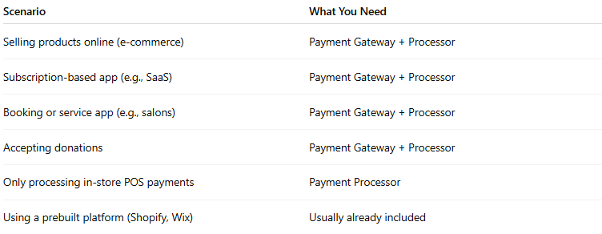
Scenario | What You Need
Selling products online (e-commerce) | Payment Gateway + Processor
Subscription-based app (e.g., SaaS) | Payment Gateway + Processor
Booking or service app (e.g., salons) | Payment Gateway + Processor
Accepting donations | Payment Gateway + Processor
Only processing in-store POS payments | Payment Processor
Using a prebuilt platform (Shopify, Wix) | Usually already included

🛠️ Recommended All-in-One Solutions
# Source: AI Source: Provided by: [Data Path: Persons Table -> ID Column: 1, Name_En Column: Motasem Essam] -> From: [ChatGPT] on [1/21/2026]

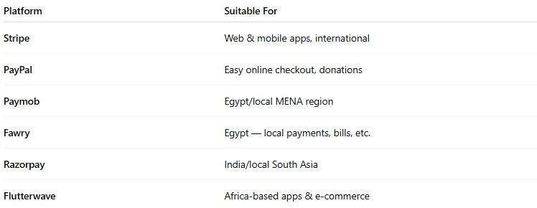

Platform | Suitable For
Stripe | Web & mobile apps, international
PayPal | Easy online checkout, donations
Paymob | Egypt/local MENA region
Fawry | Egypt — local payments, bills, etc.
Razorpay | India/local South Asia
Flutterwave | Africa-based apps & e-commerce

how Payment Gateway and Processor they work together
# Source: AI Source: Provided by: [Data Path: Persons Table -> ID Column: 1, Name_En Column: Motasem Essam] -> From: [ChatGPT] on [1/21/2026]
Great question! Let's break down how a payment gateway and a payment processor work together to complete an online or in-store payment.

🔄 How Payment Gateway and Processor Work Together
# Source: AI Source: Provided by: [Data Path: Persons Table -> ID Column: 1, Name_En Column: Motasem Essam] -> From: [ChatGPT] on [1/21/2026]
Think of a payment as a two-part process:
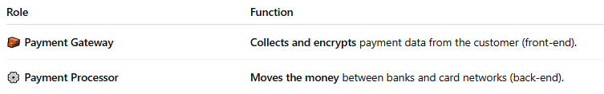

Role | Function
🧱 Payment Gateway | Collects and encrypts payment data from the customer (front-end).
⚙️ Payment Processor | Moves the money between banks and card networks (back-end).

📦 Step-by-Step Example: Online Card Payment
# Source: AI Source: Provided by: [Data Path: Persons Table -> ID Column: 1, Name_En Column: Motasem Essam] -> From: [ChatGPT] on [1/21/2026]
Let's say a customer buys something from your website:
1. 🛍️ Customer Places Order
- Enters card details on your checkout page.
- This form is powered by the payment gateway (e.g., Stripe, Paymob, PayPal).
2. 🔐 Gateway Secures the Payment Info
- The gateway encrypts sensitive data (card number, CVV).
- Sends it securely to the payment processor.
3. ⚙️ Processor Requests Authorization
- The payment processor contacts:
  - The card network (e.g., Visa, Mastercard).
  - The issuing bank (customer’s bank).
- The bank checks: Is the card valid? Is there enough balance? Is it safe?
4. ✅ Authorization Response
- The bank responds (approved or declined).
- The processor sends this result back to the gateway, and the gateway shows it on your website.
5. 💰 Settlement (Money Transfer)
- If approved:
  - The payment processor transfers the funds from the customer's bank to your merchant account (often via your acquiring bank).
  - This may take 1–2 business days.

📊 Visual Summary
# Source: AI Source: Provided by: [Data Path: Persons Table -> ID Column: 1, Name_En Column: Motasem Essam] -> From: [ChatGPT] on [1/21/2026]
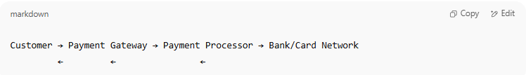
Customer → Payment Gateway → Payment Processor → Bank/Card Network
← ← ←

🛠️ Real-World Example (All-in-One)
# Source: AI Source: Provided by: [Data Path: Persons Table -> ID Column: 1, Name_En Column: Motasem Essam] -> From: [ChatGPT] on [1/21/2026]
Platforms like Stripe, Paymob, and PayPal combine both roles:
- Their gateway shows the checkout and collects data.
- Their processor handles the transaction and fund transfer.

⚠️ Why It Matters to You as a Developer or Business Owner
# Source: AI Source: Provided by: [Data Path: Persons Table -> ID Column: 1, Name_En Column: Motasem Essam] -> From: [ChatGPT] on [1/21/2026]
- You usually don’t need to deal with both separately.
- You pick a provider (like Stripe or Paymob) that offers both services in one integration.
- But it's good to understand the roles, especially if you're choosing between custom bank integrations vs third-party payment platforms.

